You will need to find and review course sections to prepare for registration. Use this reference to find course sections.

INSTRUCTIONS
- Log into Workday and enter the Academics app.

Course sections are broadly organized by level, Undergraduate and Graduate.

Depending on what’s right for you, click “Find Undergraduate Course Sections” or “Find Graduate Course Sections”.

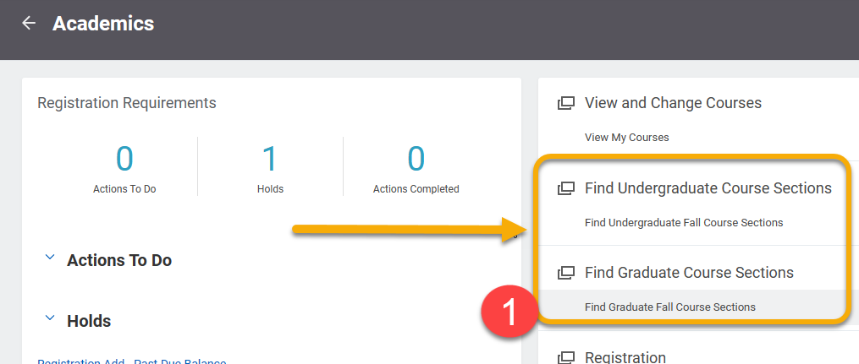
TIP: When navigating in Workday, right click on links whenever possible to open pages in a new tab. It will allow you to return to the Academic app or search results more quickly.

- The Find Undergraduate/Graduate Course Sections page features two ways to search for courses: Search Bar and Left-hand Menu.

- Search Bar: To use the search bar, type keywords, subject (e.g. CHEM or ENG) or the exact course section (ENG 102 or ENG 102-03) and press Enter or click “Search”.

- Left-Hand Menu: Use this menu to filter results by criteria. Below are some of the most commonly used search filters.

Filter | Description | Examples
Meeting Days | Narrows results by the day(s) of the week. | E.g. Mon/Wed or Tues/Thurs
Section Status | Displays courses based on capacity levels and availability | Open, Waitlist, Closed
Academic Period | Narrows courses by semester and parts of term | Fall semester, Fall Early 12 Week, Fall 1st 8 week
Delivery Mode | Narrows courses by method of delivery | Online, In-person, hybrid
Instructional Format | Narrows courses based on the format | Lab, lecture, internship
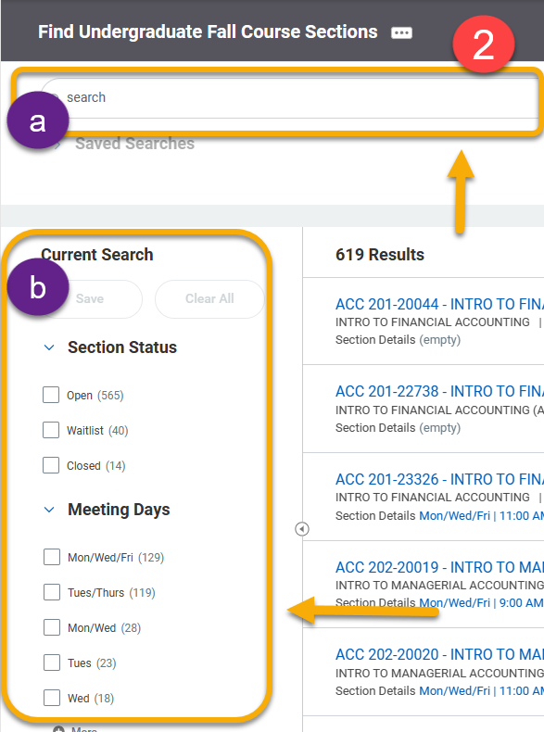

- Click the carrot symbol to the right of a course to view more course information.

- To view course details, right-click the course title and select “See in New Tab”.

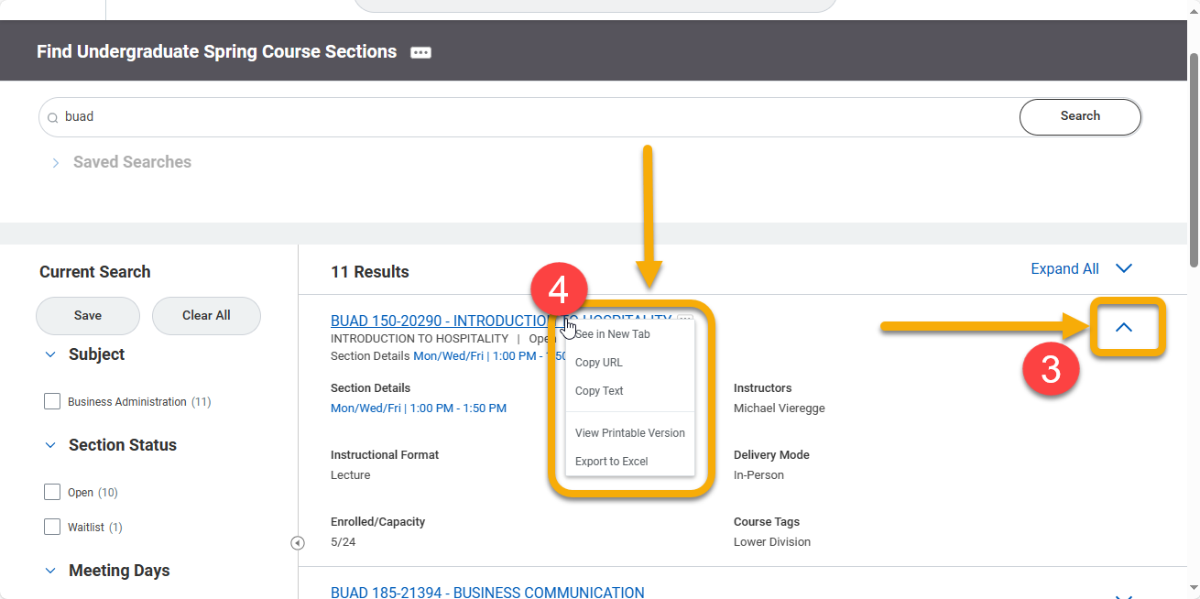
TIP: By opening the course in a new tab, you can easily close the window when finished and return to your search results.

- The View Course Section page will display all course information. Important highlights are below:

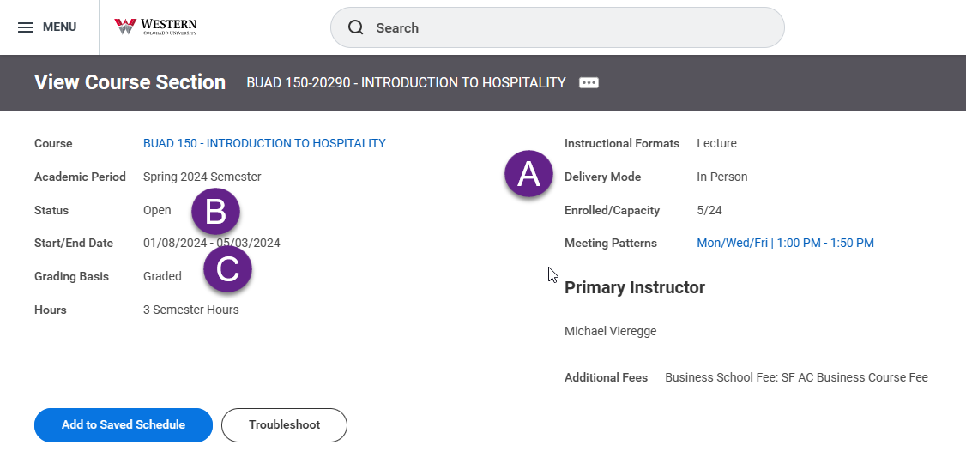
- Instructional format indicates whether the section is a lecture or lab.

- Status indicates whether the course has reached capacity. It will display either Open or Waitlist.

- Grading basis distinguishes a course as graded or pass/fail.

When the registration window is open, the blue “Register” button is visible for students.

When registration is closed, the page will display the “Add to Saved Schedule” button and “Troubleshoot” button.

TIP: Right-click “Troubleshoot” to confirm you meet course prerequisites. If you don’t meet the prerequisites, submit a course section prerequisite override from the Academics app homepage.

